Antiochian November 2020
Website: www.antiochianumc.com
Facebook: antiochumc

Dear Antioch Church,
I greet you in the name of our risen Lord and Savior Jesus Christ. Hear the words from Paul to the church at Ephesus:
³ Praise be to the God and Father of our Lord Jesus Christ, who has blessed us in the heavenly realms with every spiritual blessing in Christ. ⁴ For he chose us in him before the creation of the world to be holy and blameless in his sight. In love ⁵ he predestined us for adoption to sonship through Jesus Christ, in accordance with his pleasure and will— ⁶ to the praise of his glorious grace, which he has freely given us in the One he loves. ⁷ In him we have redemption through his blood, the forgiveness of sins, in accordance with the riches of God’s grace ⁸ that he lavished on us. With all wisdom and understanding, ⁹ he made known to us the mystery of his will according to his good pleasure, which he purposed in Christ, ¹⁰ to be put into effect when the times reach their fulfillment—to bring unity to all things in heaven and on earth under Christ.
We have redemption through His blood, our sins are forgiven. How? Through the riches of God’s grace. Why? To bring unity to all things in heaven and on earth under Christ.
You have blessed me so much with your generous gift for Pastor Appreciation. I am very grateful that God has placed me at Antioch and our journey has just started. I look forward to what God has in store for us on this journey. My desire is to stay and walk with you in and through this journey. I am truly blessed to a part of the Antioch family. ¹⁸ And pray in the Spirit on all occasions with all kinds of prayers and requests. With this in mind, be alert and always keep on praying for all the Lord’s people. ¹⁹ Pray also for me, that whenever I speak, words may be given me so that I will fearlessly make known the mystery of the gospel. Ephesians 6:18-19a.

Hear the words from Paul at the end of Ephesians:
¹⁰ Finally, be strong in the Lord and in his mighty power. ¹¹ Put on the full armor of God, so that you can take your stand against the devil’s schemes. ¹² For our struggle is not against flesh and blood, but against the rulers, against the authorities, against the powers of this dark world and against the spiritual forces of evil in the heavenly realms. ¹³ Therefore put on the full armor of God, so that when the day of evil comes, you may be able to stand your ground, and after you have done everything, to stand. ¹⁴ Stand firm then, with the belt of truth buckled around your waist, with the breastplate of righteousness in place, ¹⁵ and with your feet fitted with the readiness that comes from the gospel of peace. ¹⁶ In addition to all this, take up the shield of faith, with which you can extinguish all the flaming arrows of the evil one. ¹⁷ Take the helmet of salvation and the sword of the Spirit, which is the word of God.
God bless you in this upcoming Advent Season,

Pastor Keith

Altar Flowers
Nov 1 - Mike & Darlene Winfield

Don’t forget to turn your clocks back one hour before you go to bed on Saturday Night!

Nov 8 - Scott & Jane Francis

Nov 15 - Steve & Sally Keener

Nov 22 - Chuck & Bonnie Morton

Nov 29 – The George Strobel Family

Thank You Floyd!
We just wanted to send out a little thank you to Floyd Millikin for standing in for Linda Stukenborg during her illness. We do not have ushers, greeters, or hospitality people during this time, and Floyd has been our one-man band for all of these things.
He is nursing an injured leg himself, but still takes care of all that needs taken care of in the narthex.

Thank you from all of us, for what you do.
This Sunday is All Saints Sunday!
We will be celebrating All Saints Sunday, November 1, 2020 with a special service. We will be remembering all our loved ones who have passed since November of last year.
Linda Stukenborg wishes to thank everyone that has called, sent cards or flowers, brought food or has simply prayed for her healing. She said, “ Each time I get a call or a card, it makes my day so much better and the pain a little less.” Linda says she is slowly healing from several infections in the abdomen, but still has a long way to go. Again thank you.
Linda Stukenborg

(Please keep Linda in your thoughts and prayers as she and her family go through this very difficult time.)
Pat Pyle wishes to say a big thank you for the prayers, kindnesses, food, cards, flowers, and calls that came with her recent surgery. I appreciated everyone one of them.
Also, Mel and Pat would like to thank the Men’s group for sanding and polyurethaning their folding louvered doors. They look like new, and open and close easily. Thanks again, another job well done.
Mel & Pat Pyle

Note: This article was submitted by Emerson and Carol Keck last year and works something like our Kroger accounts. We would be spending the same amount, no extra, and the Church would receive a small percent of what we spend. I thought I would run it again this year. We don’t make a lot, but every little bit helps. I now use it all year long when I purchase anything through Amazon
AmazonSmile
Would you like to benefit Antioch Church when you buy items from Amazon? There is no downside to doing this!!
You can sign into Amazon and then sign up for AmazonSmile. When you do that you will be giving .5% of every dollar you spend to Antioch at no additional cost to you. Also, ask your friends and family to sign up for AmazonSmile and select Antioch as well.
You may have to search around on the Amazon homepage to find out how to do this; on my laptop the “button” for AmazonSmile is in the area in the upper right hand side of the homepage. When it becomes to select your charity, search for “Antioch Methodist Church”. Note: Do NOT look for “Antioch United Methodist Church”, as that is not how the “beloved” Internal Revenue Service issued our church’s tax exempt status letter.
If more than one Antioch Methodist Church shows up, select the one in Trotwood, Ohio. Once you have selected Antioch, it will continue to be your charity until you change it.
Note you MUST log into AmazonSmile to make your future purchases. The AmazonSmile homepages is virtually identical to the regular Amazon homepage.
This is a bit of an initial challenge, but it will be well worth the effort if enough of our members, members’ family members and our friends sign up and select Antioch. If this whole process is daunting, ask you kids or grandkids. They may even make some Christmas gift desires known to get you started!
Thank you,
Emerson and Carol Keck
(Hope you find this helpful, especially during this time of trying to avoid crowds.) Thank you.

Please remember all our veterans on November 11, and every day of the year. They served, that we may be a free nation. Say a special prayer for anyone who has served or is presently serving their country.

Women’s Circle
Meeting
The United Methodist Women’s Circle will meet on Monday, November 2, 2020, at 10:30 a.m. Bonnie Morton will be presenting the program this month. All ladies are welcome. Please consider joining us.

Country Fair
Time is Here!
Only Drive-Thru This Year!

The Women’s Circle is busy making plans for the annual Country Fair on Saturday, November 14, 2020, 4:00 to 6:30 p.m. Note: This is a week earlier than it has been in the past and like so many things has had to be changed to a Drive-Thru only. Country Fair work day will be on Friday, November 13 starting at 9:00 a.m.
Folks as you know, we were unable to have the Spring Dinner last March. So the only fund raiser for 2020 was the Rummage Sale. Funds raised go to help the Antioch Women’s Circle pay for their many mission projects and other things for the church that we are able to provide throughout the year.
Now, we are to Country Fair time and again we cannot host it in the usual manner. This will automatically cut down on our numbers. We will be doing a drive-thru only and this requires you to order in advance so we can plan on how much to prepare. There are order forms in the narthex, or you can call Bonnie Morton (937-687-1404) or Darlene Winfield (937-839-5726) no later than November 7, 2020.
This is why it is so important for you to spread the word and let your friends, family, and neighbors know about this event and ask them to consider giving our drive-thru a try.
Please, invite your neighbors, family, and friends to enjoy a delicious homemade meal of chicken and noodles or ham and beans, with your choice of a salad, (choices are: coleslaw, broccoli
salad, or fruit salad), (choice of French bread or cornbread), and dessert (choice of chocolate cake or apple pie) only $10.00 for adults and $4.00 for children (4-12), and under 3 is free. Quarts of ham and beans or chicken and noodles are $6.00. Your order will be brought to your car, and you can pay your total at that time. Food will be individually packaged for your convenience. When placing your order please let them know what time you would like to pick up your order. Our workers will all be wearing mask and gloves for your and our protection.

Ladies since we will be working with food, we will be required to wear mask and gloves, both for the work day and for those that will be working the night of the drive-thru. Thank you for your understanding and thank you for your support in this new drive-thru adventure.
The Circle
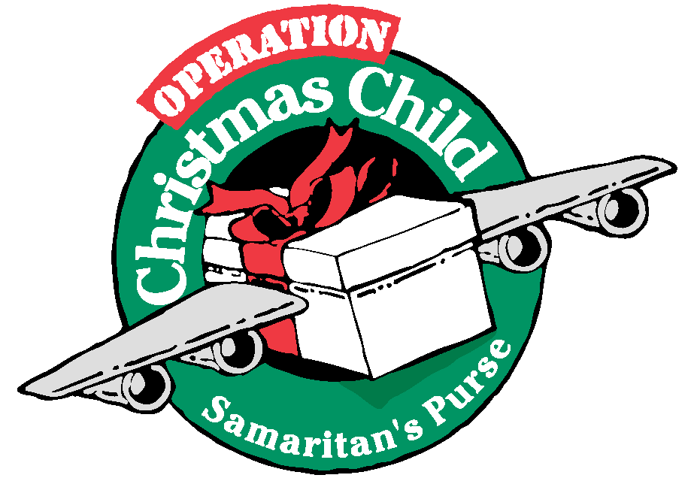

Samaritan’s Purse Christmas Child Boxes Due Soon!

Please remember the Samaritan’s Purse Christmas Child Boxes are due no later than Sunday, November 15, 2020. Boxes are still available in the narthex and in the foyer outside the office, if you still need one. Please be sure and mark your boxes for a girl or a boy and age group. See the list of suggestions for filling the boxes and the items that should not be sent for various reasons included in this Antiochian. Help to light up a child’s face for
Christmas.

These are Items Not to Include
Candy; toothpaste; gum; used or damaged items; war-related items such as toy guns, knives, or military figures; chocolate or food; seeds; fruit rolls or other fruit snacks; drink mixes (powdered or liquid); liquids or lotions; medications or vitamins; breakable items such as snow globes or glass containers; aerosol cans.
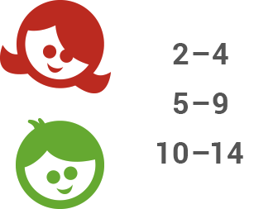

Decide whether you will pack a box for a girl or a boy, and the age category: 2–4, 5–9, or 10–14. Be sure and mark you boxes accordingly.

You can Start your box with a quality “wow” item such as a stuffed animal, soccer ball with pump, or clothing outfit that will capture the child’s attention the instant he or she opens the box. See our gift suggestions according to age and gender listed on our web site below for other fun toys, hygiene items, and school supplies to fill the shoebox. (There were five pages to copy and for those that our mailed, we cannot send that many pages.

Check online for Samaritan’s Purse Christmas Child Shoeboxes for suggestions for each age group.

Look on the Bright Side NOTE
We can see a shining rainbow, if we look beyond the rain. Pastor Keith is looking for some
Find strength to face our losses, if we’re thankful for each gain. people who would be able to share We can pick the lovely roses, if the thorns don’t get us down. at the Christmas Eve Service about
And so much time smiling, that we’ll never think to frown. a special gift they gave or received.
We can climb the steepest mountain, if our eyes turn toward This would be only 3-5 minutes
the sun. sharing time. Please see Pastor
It’s really up to us to make, our world a better one. Keith if interested.
Not Signed

ANTIOCH UMC FALL DINNER

Drive Thru Only
November 14, 2020
4:00 p.m. – 6:30 p.m.
Orders Need to be Placed by November 7, 2020

To Place Order and pick up time
call
Darlene 937 657-9070 or
Bonnie 937 687-1404

Ham & Beans or Chicken & Noodles
Cornbread or French Bread
Choice of Salad
Broccoli Salad, Fresh Fruit or
Cole Slaw
Choice of Dessert
Chocolate Cake or Apple Pie

Adults $10.00
10 yrs. & younger $4.00
3 yrs. & younger Free

Quart of Ham & Beans or Chicken & Noodles $6.00

Antiochian
November 2020
Antioch United Methodist Church
10301 Wolf Creek Pike
Trotwood, OH 45426-4259
(937-837-6348)

Pastor Keith Smallenbarger: Cell (937-510-5549)
Newsletter E-Mail: antiochian@frontier.com
Office E-Mail: antiochoffice@frontier.com
Website: www.Antiochumc.org
Facebook: antiochumc

DATED MATERIAL ENCLOSED RETURN SERVICE REQUESTED
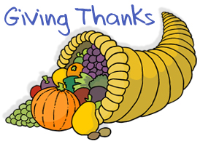
Come Experience the Transforming
Love of God with Us…..
Sunday School 9:45 a.m. (Virtual at this time.)
Worship Celebration 11:00 a.m.

